**Institute of Information Technology (IIT)**

**Jahangirnagar University**



**Course Code:** MICT 5402

**Course Title:** Advanced Machine Learning

**Assignment - 02**

**Submitted to:**

Jesmin Akhter

Professor

IIT, JU

**Submitted by:**

Name: Md. Shakil Hossain

Roll No: 1061

MSc 2nd Semester

IIT, JU

**Submission Date:** 10/04/2025

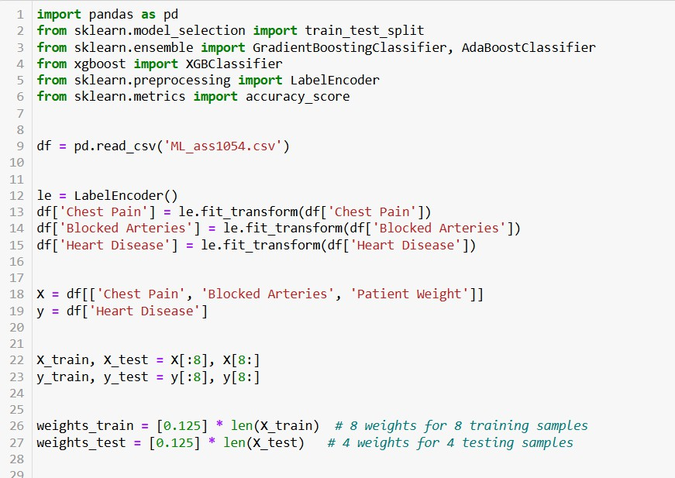Code:

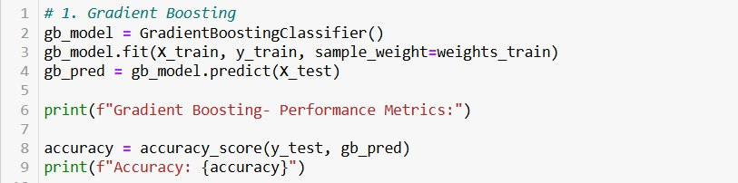Using Gradient Boosting:

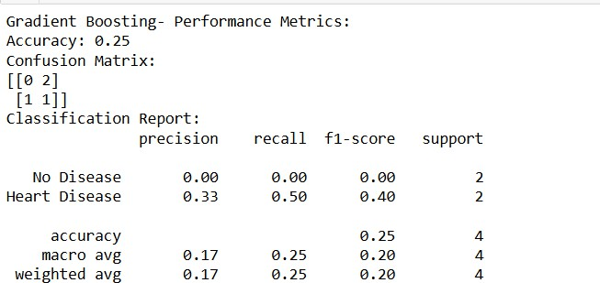Output:

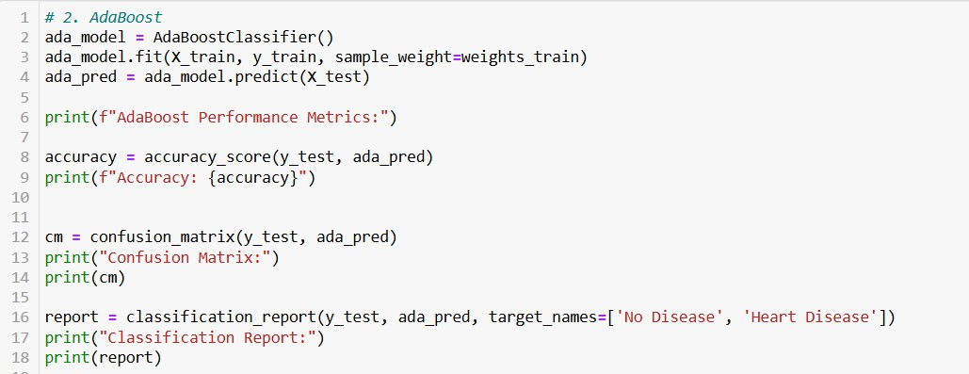Using AdaBoost:

Output:

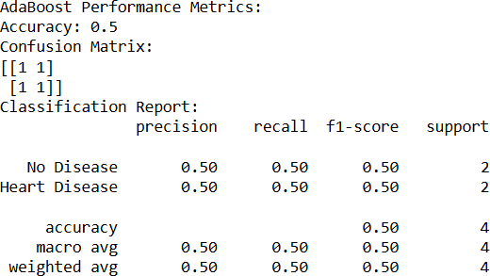

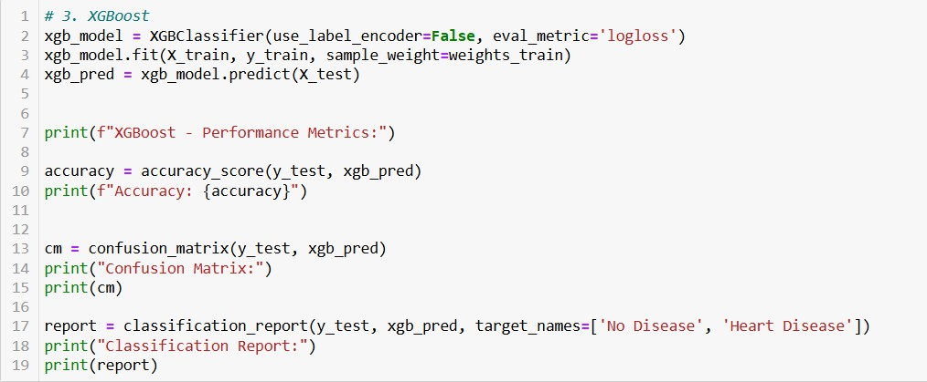Using XGBoost:

Output:

